

**April 15, 2024 – August 16, 2024**

Supervised by : Prof McLaughlin & Dr Lubarsky

Electronics Internship report

***Ulster University***

***– Belfast –***

***Northern Ireland***

Fannie BICHEMIN – Majeure électronique

Ecole nationale superieure de l’electronique et de ses applications

Table of contents

**Acknowledgment** 3

**Introduction** 4

**Company information** 6

**PROJECTS CARRIED OUT** 7

Project n°1 - OpenMV camera 7

**Introduction** 7

**Getting started** 8

**Schematic study & PCB improvement** 9

Project n°2 - Pulse sensor : 13

**Introduction** 13

**Processing Visualizer** 14

**Conclusion** 15

Project n° 3 - Polyurethane 16

**Introduction** 16

**Experiments & Results** 16

**Video of this project** 18

**Conclusion** 18

**Introduction** 19

**Study of the medical devices** 19

**Conclusion** 19

**Bibliography** 20

**Annexes** 22

**1.** **OpenMV Camera – Full report** 22

**2.** **Polyurethane – Full report** 22

**3.** **Oxygen & Pulse rate monitor – Full report** 22

**4.** **Tracker** 22

List of Figures

**Figure 1** : Northern Ireland map, Northern Ireland - Wikipedia 4

**Figure 2 :** Location of Ulster University 4

**Figure 3 :** Ulster University Buildings, Belfast City Campus University of Ulster - e-architect 4

**Figure 4** Camera H7 r2 board 7

**Figure 5 :** Device designed 7

**Figure 6** : New device design 8

**Figure 7** **:** Find rectangle, Ellipse drawing, Hello world drawing – OpenMV codes 8

**Figure 8 :** Schematic of OpenMV Camera H7 R2 electronics board given by the developers 9

**Figure 10 :** Legend of the PCB 10

**Figure 11 :** Schematic of the power supply for the camera H7 R2 board 10

**Figure 12 :** Schematic of the image sensor 11

**Figure 13 :** Schematic 12

**Figure 14 :** Pulse sensor 13

**Figure 15** : Live visualization of Pulse Signal on Arduino Serial Plotter 13

**Figure 16 :** Cardiac waveforms 14

**Figure 17 :** Display of my heart rate and of my BPM (Beats Per Minute) in real time thanks to Processing visualizer 14

**Figure 18 :** Visualization in Arduino's "Serial Monitor” 14

**Figure 19 :** Water taxi - Artemis Technologies 16

**Figure 20 :** First experimental set-up : strain gauge sensors with moulds 17

**Figure 21** : Polyurethane poured into the mould (left image) and water pouring (right image) 17

**Figure 22 :** Chart of each sensor (on the left) and force (Newton) of each sensor when the set-up is underwater 17

**Figure 23 :** Polyurethane poured on Arduino, polyurethane after few minutes and polyurethane after few hours (from left to right) 18

**Figure 24 :** Water pouring on an Arduino protected with polyurethane 18

**Figure 25 :** Electronics devices tested 19

# **Acknowledgment**

# **Introduction**

For 4 months and a half, I did an internship in electronics and IT in the field of medical research in Belfast, Northern Ireland.

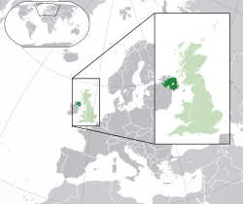

Northern Ireland is located in the North-East of the Island of Ireland and is a part of the United-Kingdom.

**Figure 1** : Northern Ireland map, Northern Ireland - Wikipedia

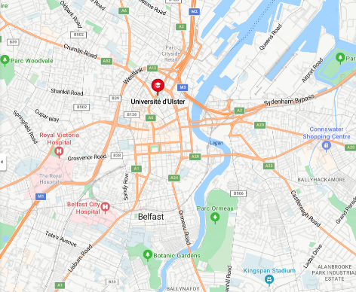

**Figure 2 :** Location of Ulster University

My internship took place at Ulster University, a university located in Belfast, Northern Ireland.

Belfast, with a population of 350 000 inhabitants, is the capital city of Northern Ireland. The university is located in the heart of the city and is comprised of several buildings.

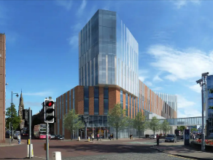

Ulster university is divided into many departments : engineering, artistic, cultural, sport…

I was in engineering department and my desk was in an office with 15 other desks. It was an office where people worked on different projects.

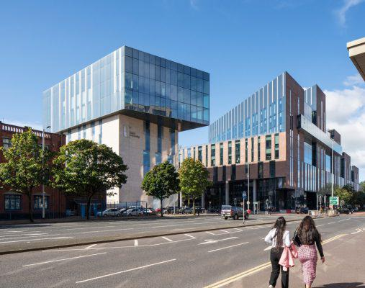

In the building, I could also went to the laboratories to sold and to take some components for my project (boards, breadboard, cables, sensors, batteries).

**Figure 3 :** Ulster University Buildings, Belfast City Campus University of Ulster - e-architect

I was under the supervision of Prof McLaughlin and Dr Gennady Lubarsky. Prof McLaughlin leads a team of researchers and Dr Lubarsky is a searcher. He explained to me my tasks and helped me through the months of my internship.

I worked on different projects, did some experiments and I wrote reports. I learned how to use many software (OpenMv IDE, Keil studio, Mbed studio, MicroVision, Visual Studio, Nrf connect) and I studied many sensors and electronic boards (DHT 11, seed xiao nrf 52840, camera H7 R2 board, pulse sensor, nrf52840 Dongle).

My main project was to update an electronic board used to control an open MV camera. I also studied polyurethane efficiency to protect electronics components and I tested oxygen and heart health monitors to compare parameters.

# **Company information**

Ulster University was created in 1865. It contains 4 campuses and enable students to discover many fields. For example, it is possible to learn about History, Drama, Music, Sport, Engineering, Computing or Business.

# **PROJECTS CARRIED OUT**

## **Project n°1 - OpenMV camera**

### **Introduction**

The first project I did was to adapt an electronic board. It was the board of an OpenMV camera H7 R2. It is a camera which can be used thanks to machine vision. This device is an open-source and anyone can contribute to the OpenMv camera GitHub : <https://github.com/openmv/openmv.git> .

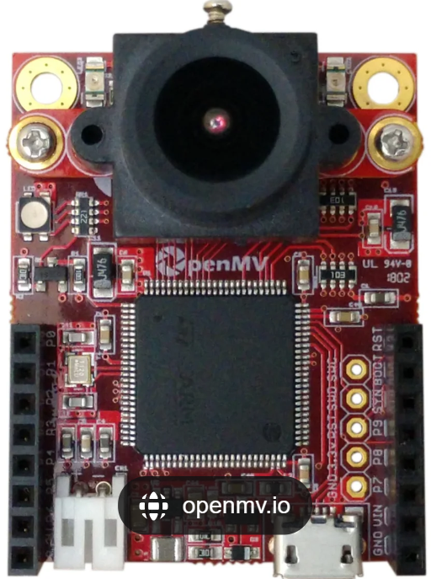

**Figure 4** Camera H7 r2 board

My supervisor need to use this camera in a medical project. Few years ago, he created a device which could analyze tests ( blood, saliva, urine) and shows result to patient thanks to a mobile phone app. They had to design a kit to enable people to do every step alone. The device created is below :

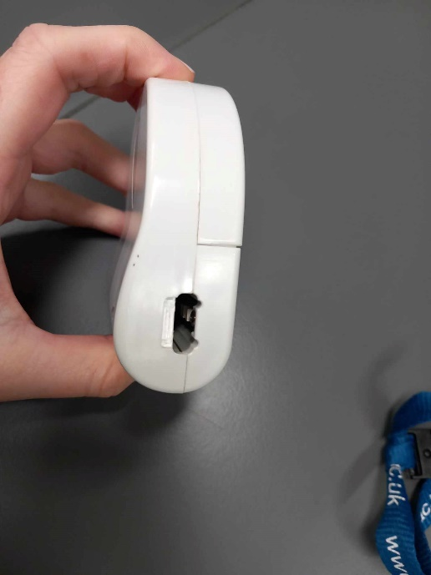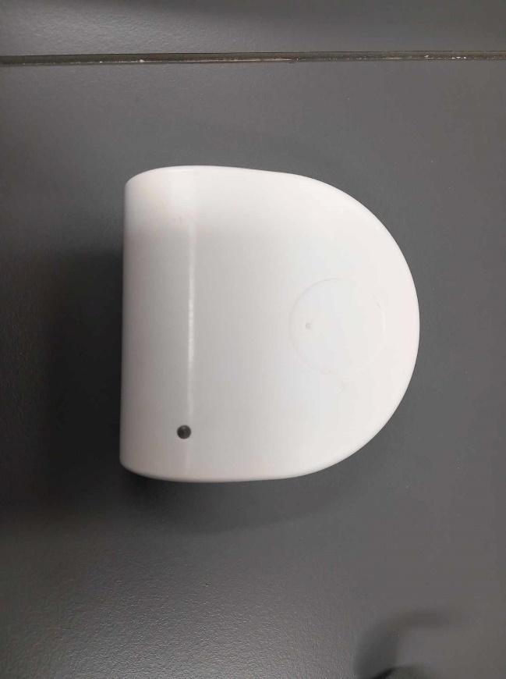

**Figure 5 :** Device designed

In order to improve this project, my supervisor wanted to add an OpenMV camera. He designed a new prototype to fits with the new electronics components :

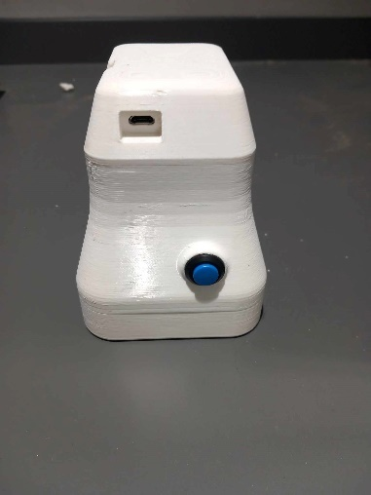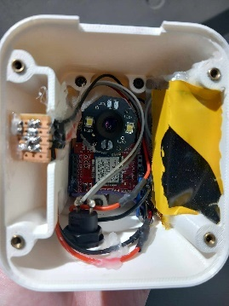

**Figure 6** : New device design

This new version was done with a camera which works with LED and WIFI connection.

My task was to create a PCB which included the OpenMV camera H7 R2, a Bluetooth module and a battery in order to do a new version of this project.

### **Getting started**

First of all, I tested a lot of codes thanks to OpenMv IDE to learn more about the camera H7 R2. It was really simple because many examples are given by the developers, of this electronic board, on their GitHub.

For example, I tried the “ellipse”, the “hello world drawing” code and the “find rectangle” example as shown below :

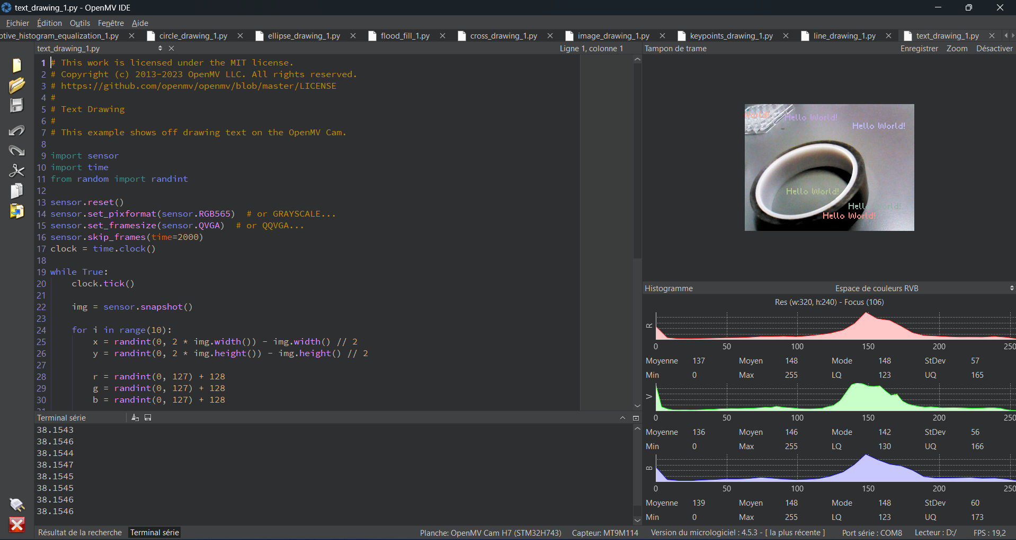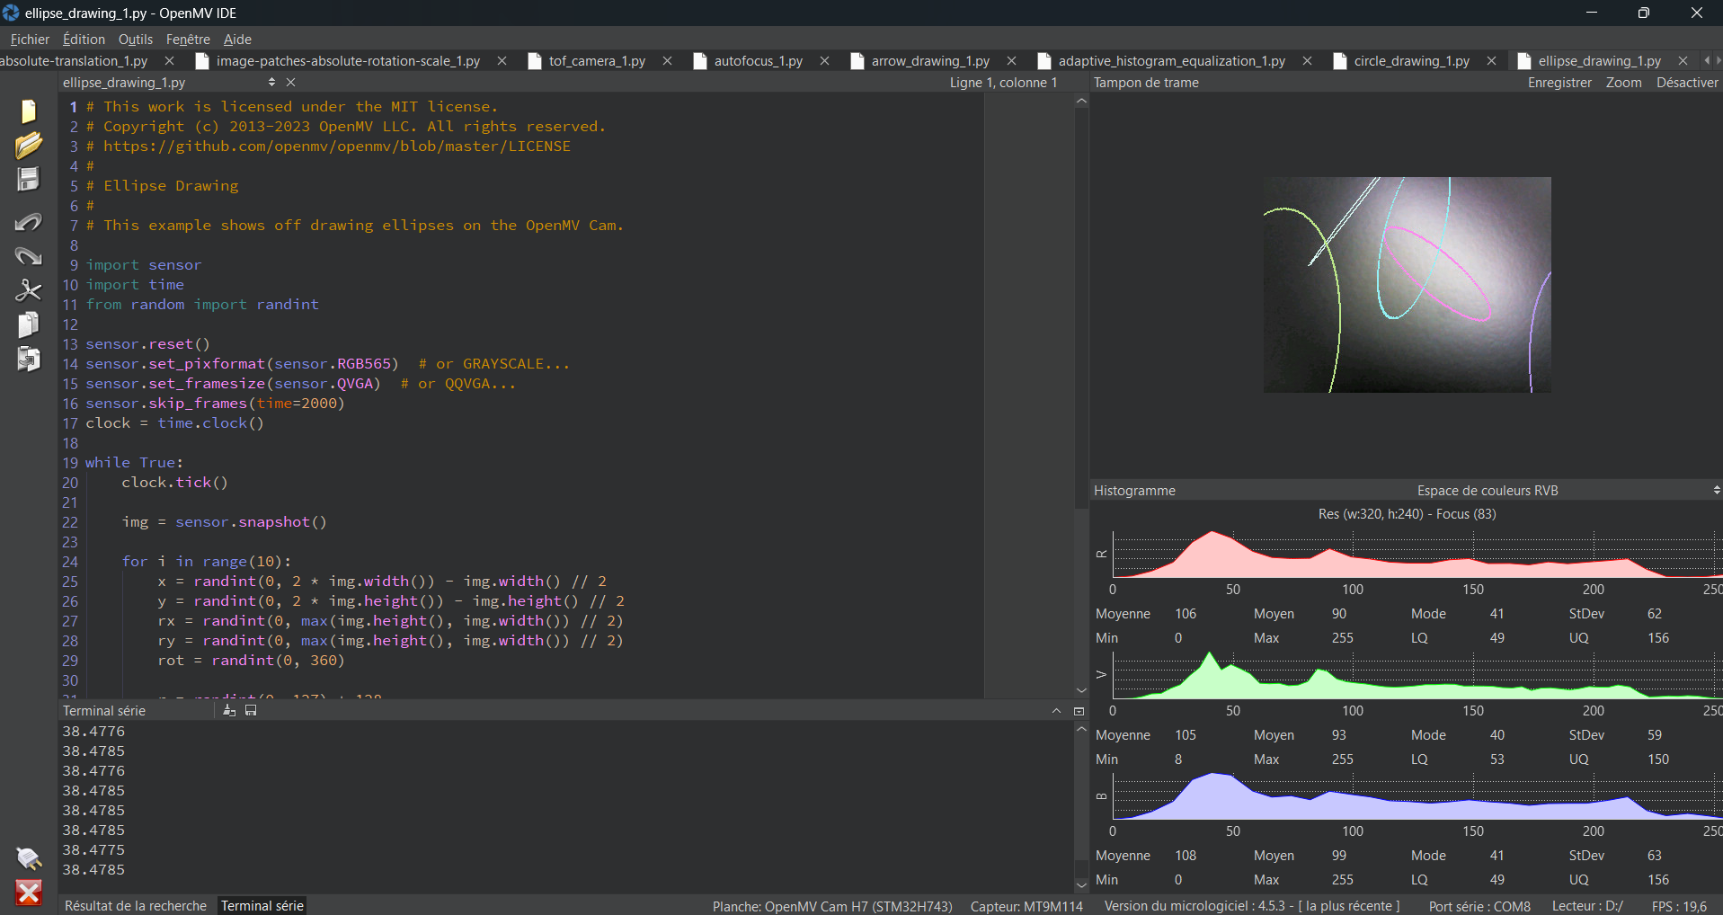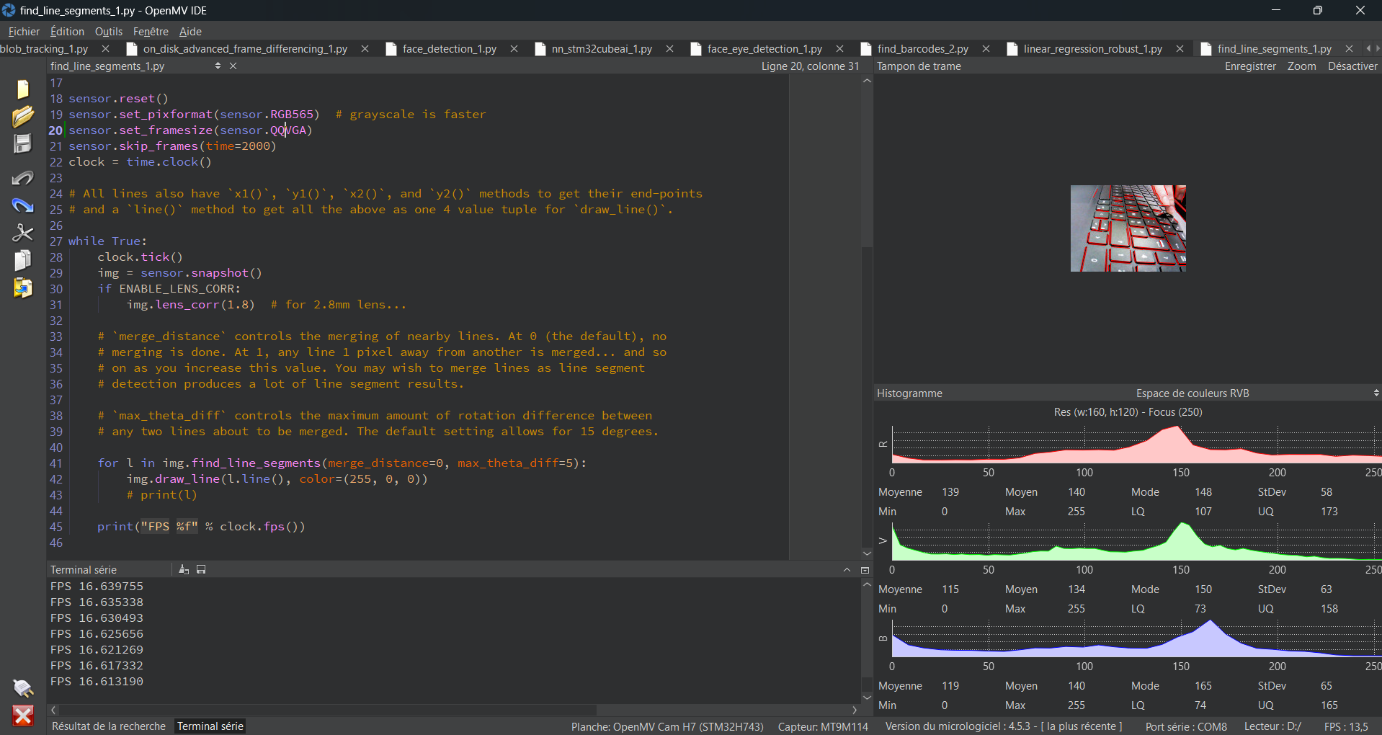

**Figure 7** **:** Find rectangle, Ellipse drawing, Hello world drawing – OpenMV codes

### **Schematic study & PCB improvement**

The main first step was to discover the electronic board of OpenMV H7 R2 to understand it and to try to improve its design. In fact, I needed to modify the schematic to adapt it to my supervisor’s project.

The schematic of this board is available on the internet :

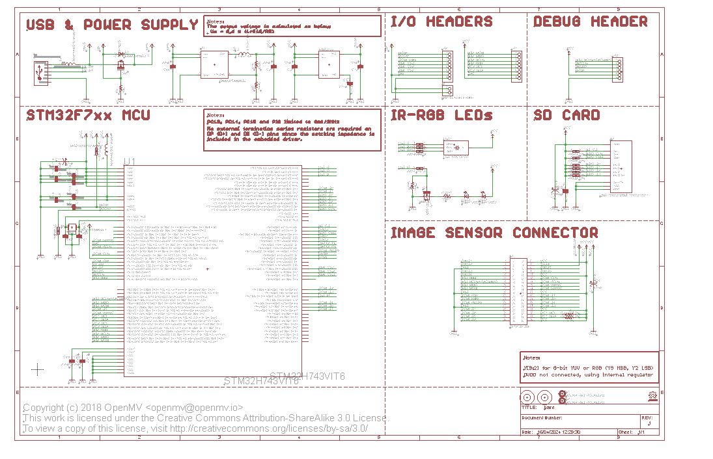

**Figure 8 :** Schematic of OpenMV Camera H7 R2 electronics board given by the developers

The schematic is design with Eagle and shows all the components used on the PCB.

We can quickly analyze this document :

* The microprocessor used is a STM32.
* There is a RGB LED which is used to highlight the status of the board and the camera.
* Many headers are available to connect sensors or other components to the board.
* A regulator and a converter are used to supply power on the electronics board
* The last main component is a SD card to collect data.

The last part of this schematic is linked to power supply. There are two main components whose usefulness I explain in the following legend (Fig x)

In order to have a better understanding of the link between all the components, I draw a legend to highlight the role of each component and to see different voltages of the PCB :

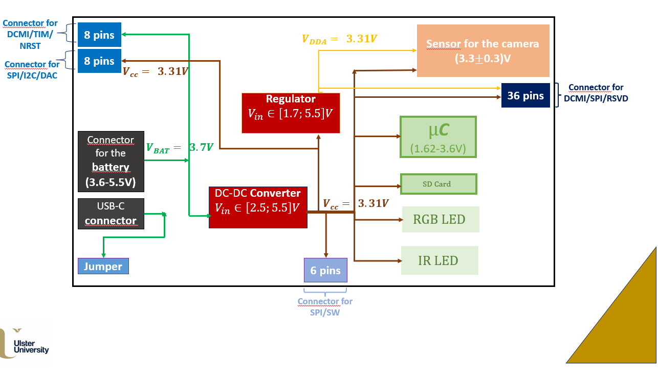

**Figure 9 :** Legend of the PCB

The next step was to talk with my supervisor about the way he wanted to use this PCB to improve the design. I had to think about which components could be totally removed, which ones could be replaced and which ones could be added to ensure that the electronic board will match to the project in which it is used.

There were few components to replace: microUSB connector and pin headers. In fact, it is better to use a USB-C connector because this is the new standard and to add headers for the pins needed. Then, I added a connector for a Micro-Lipo battery to supply power thanks to a battery.

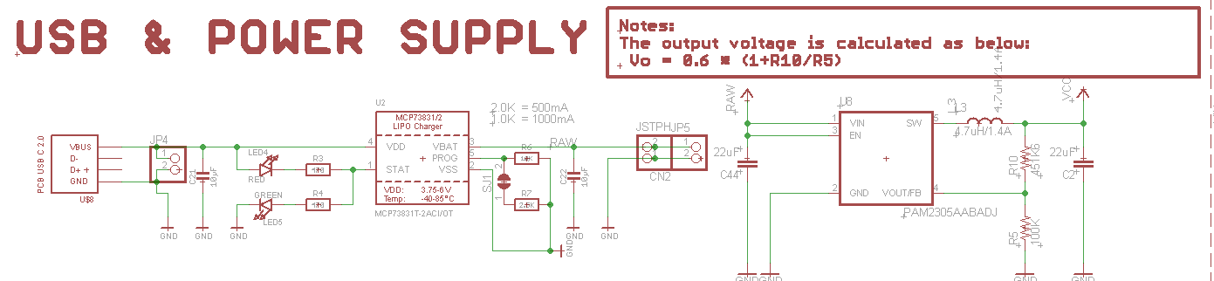

**Figure 10 :** Schematic of the power supply for the camera H7 R2 board

Then, we integrated the image sensor in the main PCB instead of its connector. In fact, it is easier to have an electronic board with the camera directly sold on it rather than having to screw another PCB.

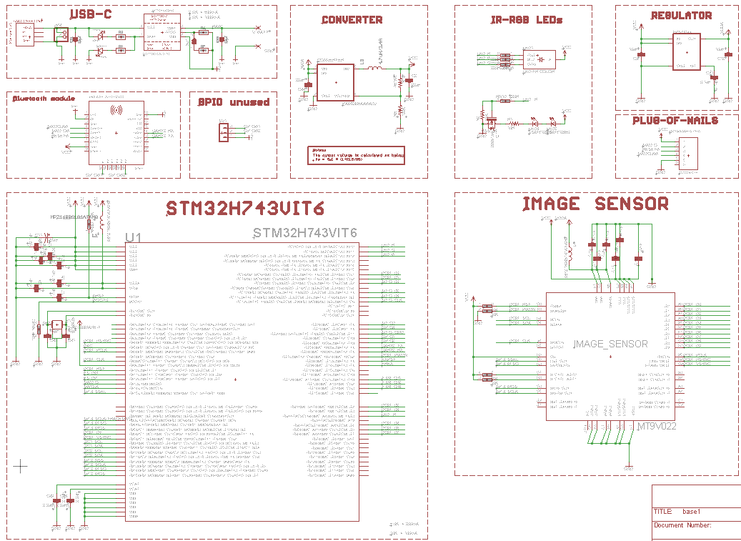

**Figure 11 :** Schematic of the image sensor

The image sensor schematic was also given on GitHub.

In order to be able to broadcast data thanks to Bluetooth, I needed to integrate a Bluetooth module to the PCB. My supervisor had a lot of Nordic [1] components so I needed to learn how to program these components with Nordic software : nRF connect. I did it and was able to xxxxx

This module is also a Bluetooth Low Energy (BLE), has a SPI interface, an antenna and a Nordic Radio Chipset.

After completing all these changes, here is the final version of the schematic :****

**Figure 12 :** Schematic

The next step was to create the board and to place components.

I designed four versions of the board :

More details about this project available here : click

## **Project n°2 - Pulse sensor :**

### **Introduction**

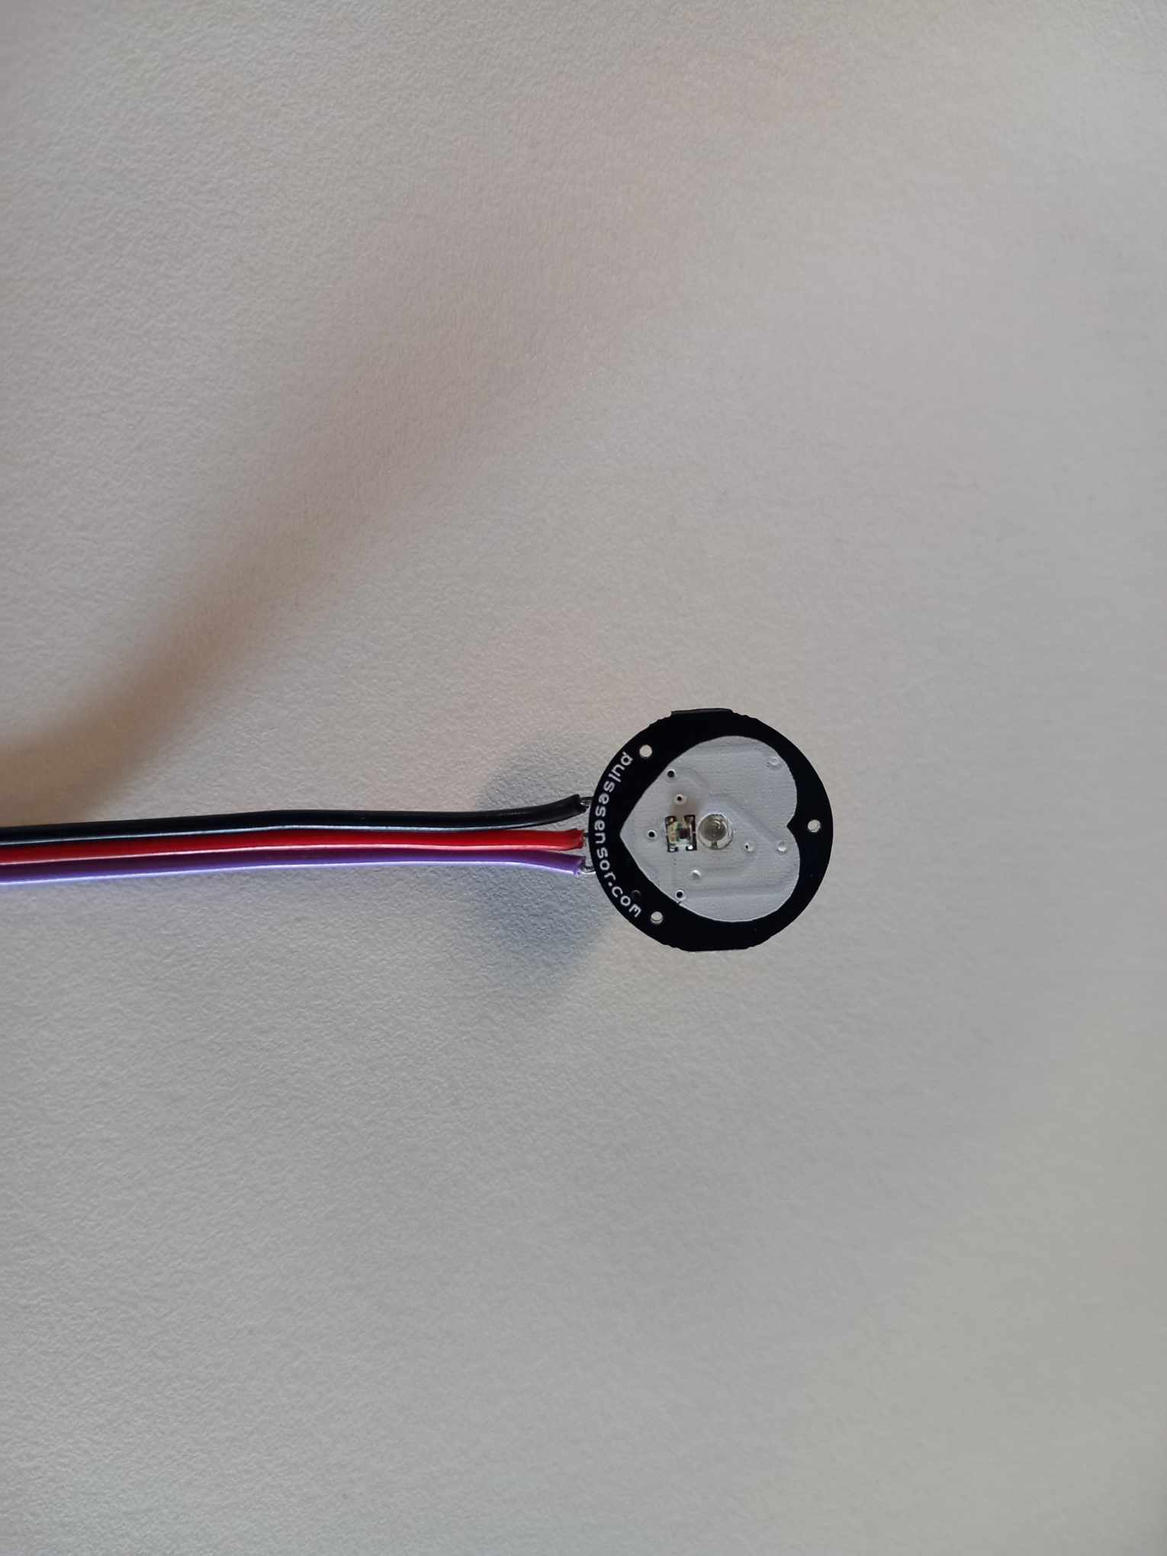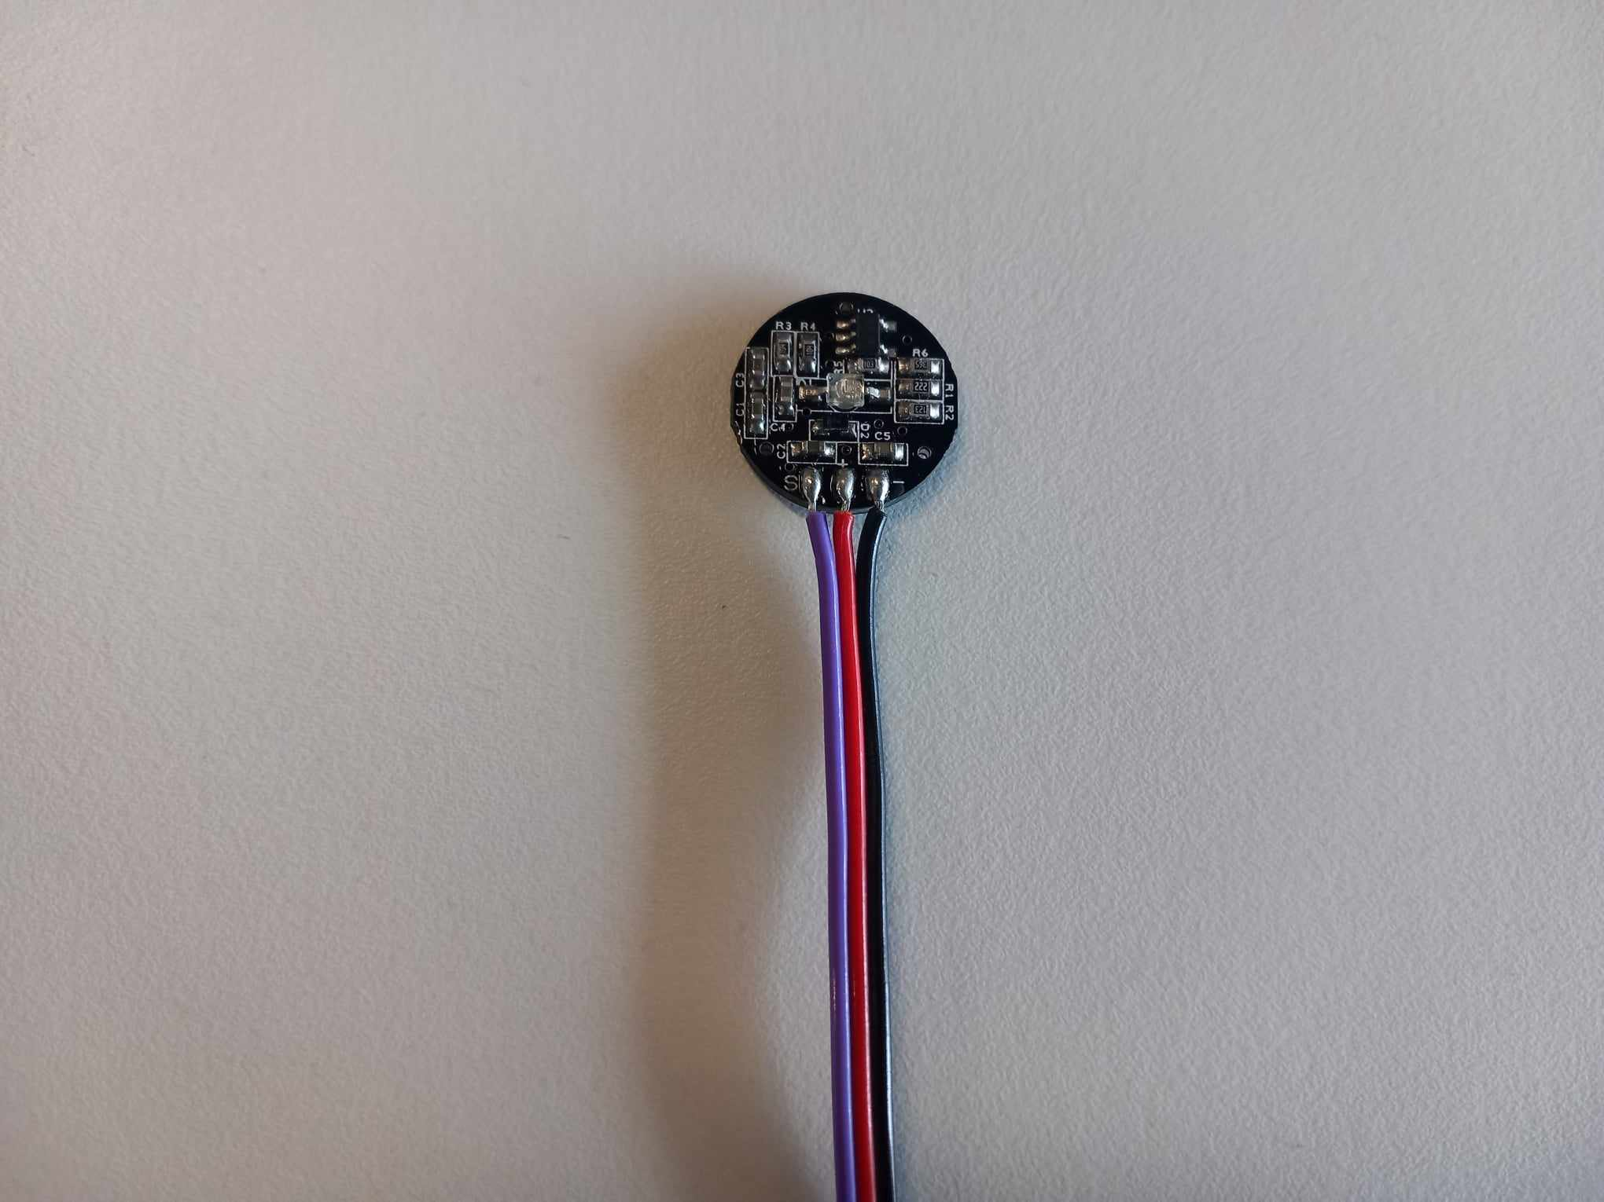

**Figure 13 :** Pulse sensor

Pulse sensor is used to monitor heart pulses. This sensor is compatible with many Arduino boards and heart-rate monitoring is open source. Many examples and advice, to create a project with this sensor, are available online. My supervisor asked me to implement codes in order to be able to see live heartbeat waveform. The first step was to use Arduino IDE to test codes and to use serial monitor and plotter.

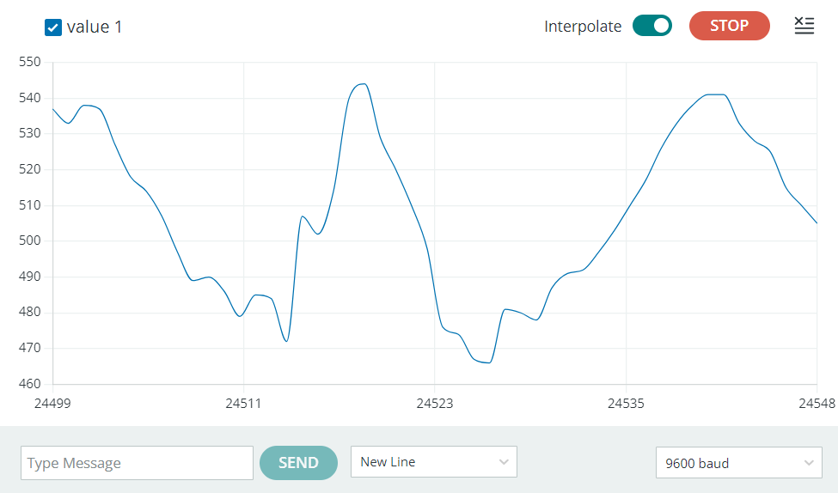

**Figure 14** : Live visualization of Pulse Signal on Arduino Serial Plotter

This live visualization was a first test which allowed me to discover pulse sensors but I needed to obtain more precise values.

### **Processing Visualizer**

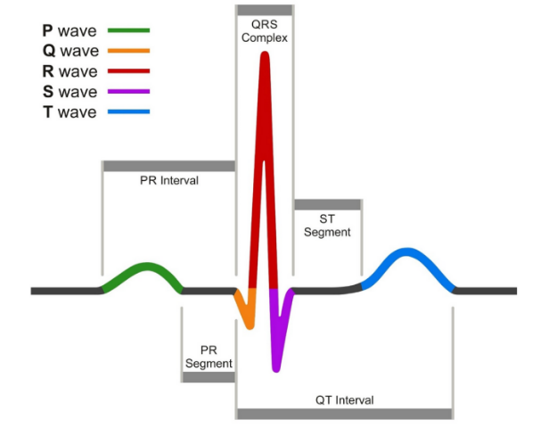This heartbeat waveform is not accurate enough. So, thanks to research on the Internet, I found a special tool (Processing Visualizer) which is more precise.

**Figure 15 :** Cardiac waveforms

**Figure 16 :** Display of my heart rate and of my BPM (Beats Per Minute) in real time thanks to Processing visualizer

[ECG Quiz: Interpreting cardiac waveforms (ems1.com)](https://www.ems1.com/ems-products/medical-monitoring/articles/quiz-interpreting-cardiac-waveforms-r3tCWbZuBkI5Ol9M/)

* We can notice that the heartbeat waveform is consistent with conventional data. In addition, the Beats per minutes are also consistent with known values. In fact, according to British heart foundation website, a “normal” resting heat rate should be between 60 to 100 beats per minute.

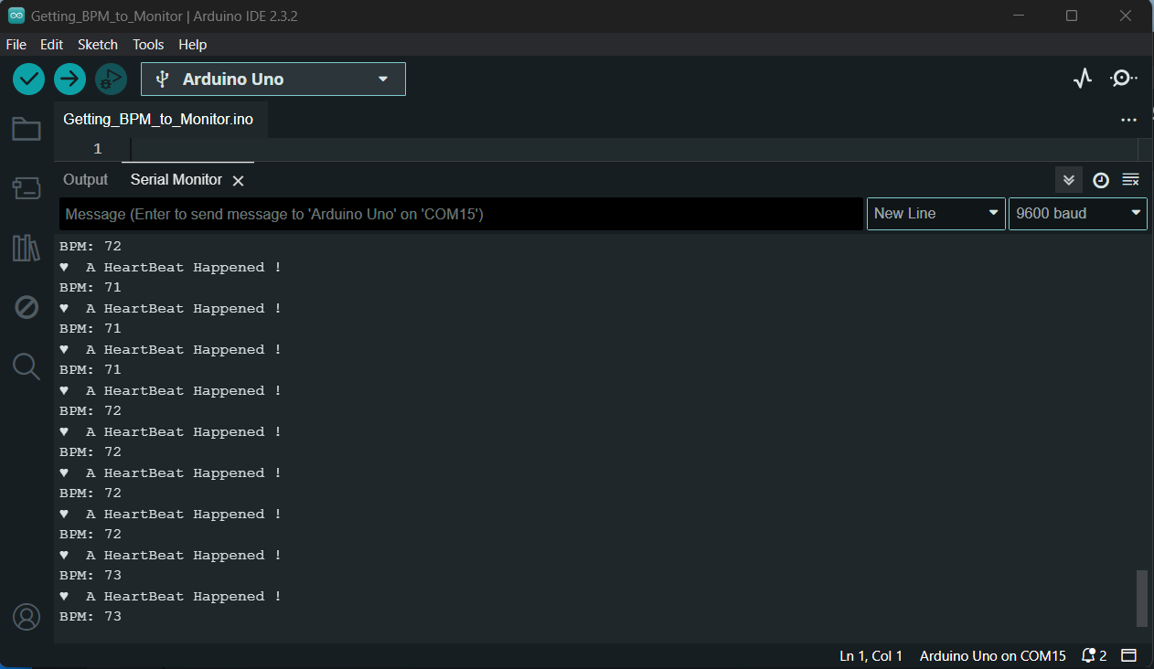

**Figure 17 :** Visualization in Arduino's "Serial Monitor”

It is also possible to monitor each heartbeat thanks to a code which enable an LED of the Arduino board to blink for each heartbeat. The serial monitor of Arduino is used to send a heartbeat alert and to print the BPM in real-time.

* We can notice that BPM printed are consistent with “normal” values.

### **Conclusion**

## **Project n° 3 - Polyurethane**

### **Introduction**

This project was to test a mixture, called polyurethane, used to protect electronics from water. The aim was to find a way to correctly pour polyurethane on electronics before putting electronics underwater.

This experiment was really important because it was for a company, [Artemis technologies](https://www.artemistechnologies.co.uk/efoiler/) which is specialized in “lead[ing] the decarbonisation of the maritime industry through the design and development of transformative technologies”. The main aim was to use strain gauge sensors and to protect them thanks to polyurethane.

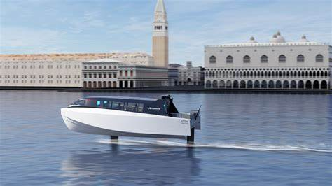Artemis technologies is a company which develops commercial vessels. To monitor the movement of the bottom part of their boats, they need to use strain gauge sensors. These sensors will be placed in a water-isolated space on their boat but will still be exposed to humidity.

**Figure 18 :** Water taxi - Artemis Technologies

[Artemis Technologies | Hydrofoil EF-12 Escape Water Taxi](https://www.artemistechnologies.co.uk/ef-12-escape-water-taxi/)

This is why it was necessary to study a product that would enable the sensors to be protected from water. We therefore experimented with polyurethane to ensure that electronic components would work even when in contact with water.

### **Experiments & Results**

Our experiments were to protect electronic devices (strain gauge sensors and Arduino nano 33 IOT) with polyurethane before placing them underwater to check the efficiency of this product.

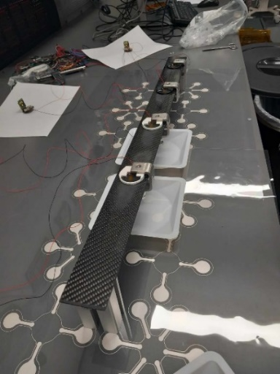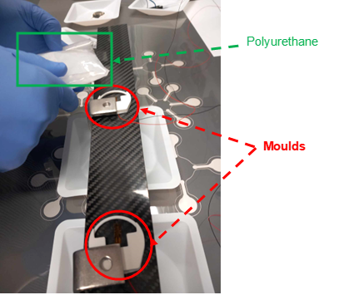

**Figure 19 :** First experimental set-up : strain gauge sensors with moulds

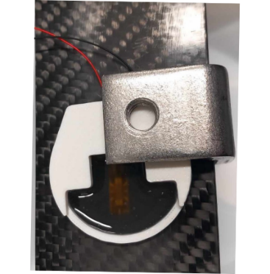

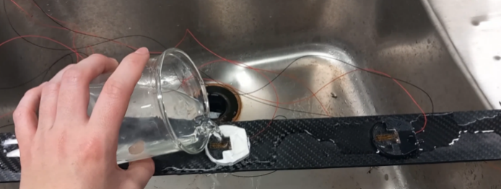

**Figure 20** : Polyurethane poured into the mould (left image) and water pouring (right image)

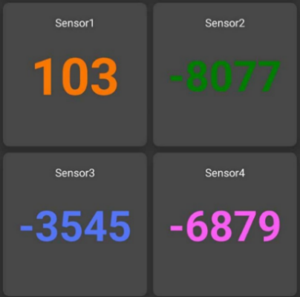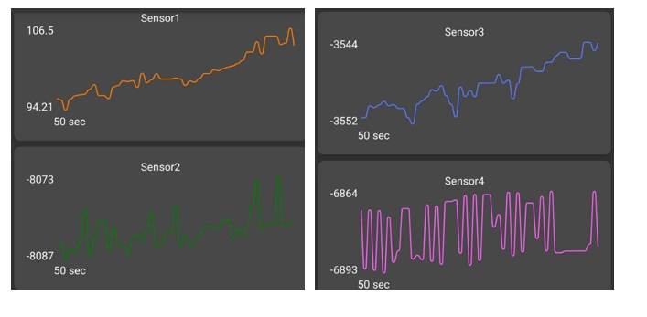The charts below were done with B24 toolkit when the sensors were underwater. This is a mobile phone app used to collect data from gauge strain sensors.

**Figure 21 :** Chart of each sensor (on the left) and force (Newton) of each sensor when the set-up is underwater

Thanks to these analysis we can say that sensors are still working even underwater. We can add that these charts and force values are similar to data that we collected before the beginning of the experiment.

We also tested polyurethane mixture with another electronics device : an Arduino Nano 33 IoT.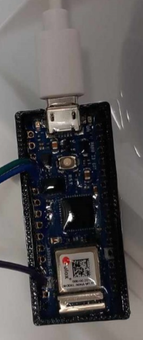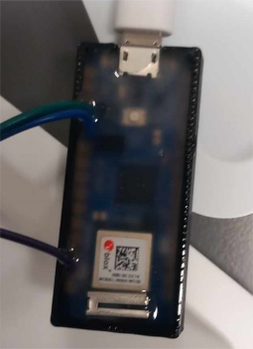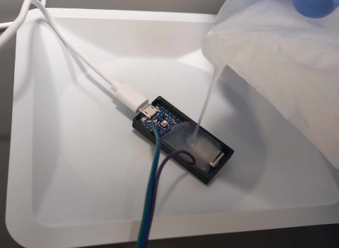

**Figure 22 :** Polyurethane poured on Arduino, polyurethane after few minutes and polyurethane after few hours (from left to right)

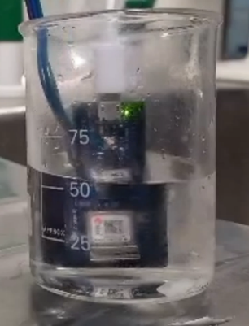

**Figure 23 :** Water pouring on an Arduino protected with polyurethane

The LED still works underwater which once again highlights the product’s efficiency.

There was a problem with this experiment because we could not test Bluetooth mode. In fact, as we covered the whole PCB with polyurethane, we could no more have access to the reset button and we were no more able to connect the board to a computer.

### **Video of this project**

I made a video to show experiments and results. This video is available with this link : <https://drive.google.com/file/d/1cIhoycqqXALLKmagpOhw1g2ZCEOiyJQS/view?usp=sharing>

### **Conclusion**

The most import thing we proved is that polyurethane is useful to protect electronics from water. When we poured water on electronics, LEDs were still blinking and it was also still possible to get force values from strain gauge sensors.

**Project n° 4 - Oxygen & Pulse rate monitor**

### **Introduction**

I tested four different medical devices (oximeter, ECG recorder and heart health monitor) to compare their accuracy, the results they provide and the way they work.

### **Study of the medical devices**

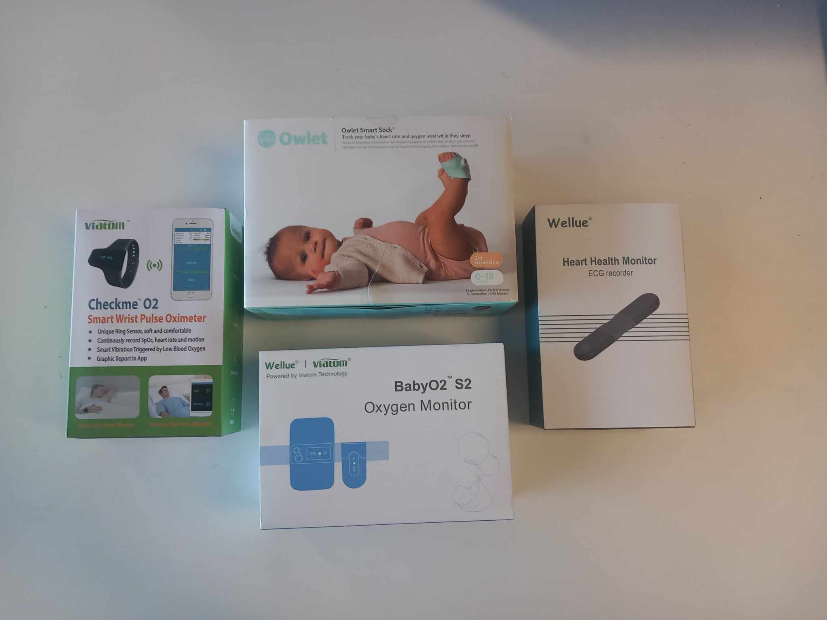

**Figure 24 :** Electronics devices tested

# **Conclusion**

# **Bibliography**

***Nrf Connect :*** There is a computer app used to develop codes for nRF devices. There are many parameters useful to test and monitor Nordic devices. There is also a mobile app used with Bluetooth communication.

***Visual Studio Code :*** This is a software used to create project (Java, C, Python,…) from scratch. Many examples are available and there are a lot of extensions that we can add depending on our devices.

***Open Mv IDE :*** This is a software that we need to use to run on Open MV Camera thanks to python code. Many examples are available.

***B24 :*** This is a software used to collect data from strain gauge sensors.

***LightBlue :*** This is a software used for Bluetooth communication.

* **Camera H7 R2 :**

Datasheet : [OpenMV-H7 Datasheet (sparkfun.com)](https://cdn.sparkfun.com/assets/a/3/f/d/9/OpenMV-H7_Datasheet.pdf)

GitHub : <https://github.com/openmv/openmv.git>

* **Pulse sensor :**

Datasheet : [Pulse Sensor Datasheet.pdf (components101.com)](https://components101.com/sites/default/files/component_datasheet/Pulse%20Sensor%20Datasheet.pdf)

Official website : [Heartbeats in Your Project, Lickety-Split ♥ – World Famous Electronics llc. (pulsesensor.com)](https://pulsesensor.com/)

GitHub : <https://github.com/WorldFamousElectronics/PulseSensorPlayground.git>

* **nRF 52840 :**

Datasheet : [nRF52840 Product Specification (nordicsemi.com)](https://infocenter.nordicsemi.com/pdf/nRF52840_OPS_v0.5.pdf)

* **XIAO nRF52840 :**

Seller : [Seeed Studio XIAO nRF52840 Sense - TinyML/TensorFlow Lite- IMU / Microphone - Bluetooth5 - Seeed Studio](https://www.seeedstudio.com/Seeed-XIAO-BLE-Sense-nRF52840-p-5253.html)

Tutorial : [Bluetooth low energy Services, a beginner's tutorial - Bluetooth low energy - nRF5 SDK guides - Nordic DevZone (nordicsemi.com)](https://devzone.nordicsemi.com/guides/short-range-guides/b/bluetooth-low-energy/posts/ble-services-a-beginners-tutorial)

* **Polyurethane :**

Features : A700000007350082.pdf

Mixing instructions : 0900766b8158003f.pdf

# **Annexes**

### **OpenMV Camera – Full report**

### **Polyurethane – Full report**

### **Oxygen & Pulse rate monitor – Full report**

### **Tracker**

ANNEX n°1 : Open MV Camera

1. [Nordic](https://www.nordicsemi.com/) is a company which develops wireless communication semiconductors